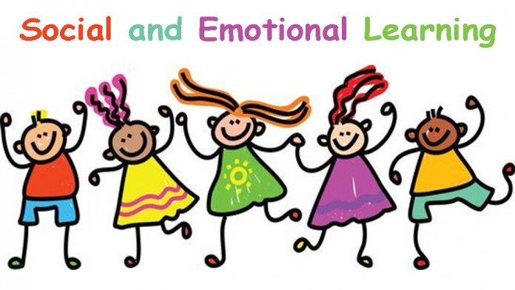
Social-Emotional Unit
Unit 1: Affective Development
- Social-Emotional Self-Understanding
- Goal Setting

Research Units
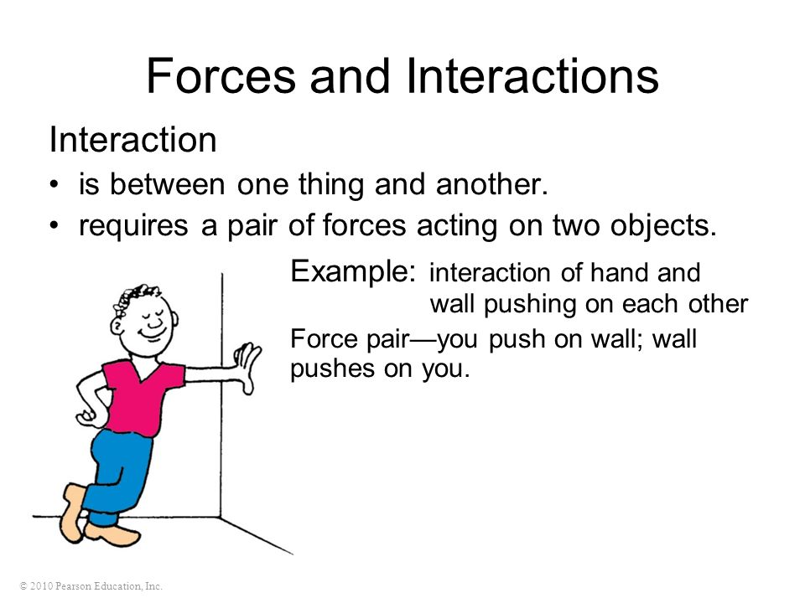
Unit 2: Forces and Interactions

Unit 3: Economics

Unit 4: History

EAGLE Expo Unit
Unit 5: Personal Interest Research Project

