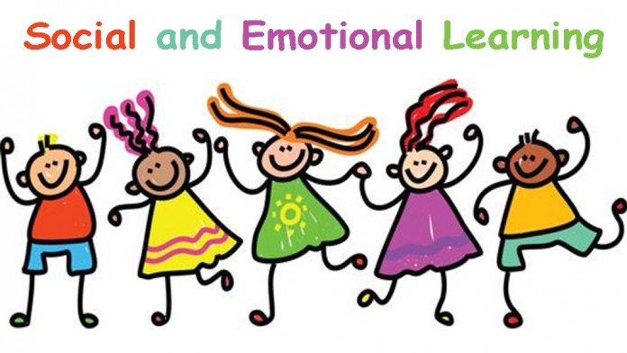
Social-Emotional Unit
Unit 1: Affective Development
- Social-Emotional Self-Understanding
- Goal Setting

Research Units
Unit 2: Energy

Unit 3: Colorado History

Unit 4: Waves / Governing Colorado (choice)

EAGLE Expo Unit
Unit 5: Personal Interest Research Project
