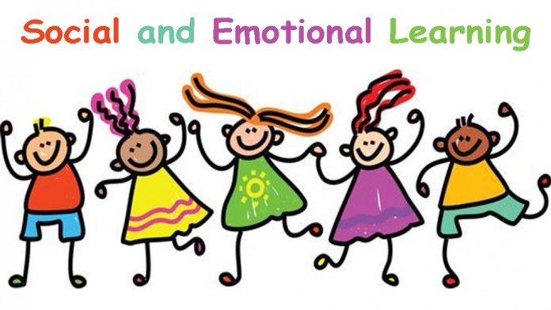
Social-Emotional Unit
Unit 1: Affective Development
- Social-Emotional Self-Understanding
- Goal Setting

Research Units
Units 2/3 (combined concepts):
Matter and Energy in Organisms and Ecosystems
Earth’s Systems
Unit 4: Colonial America / Revolutionary War

EAGLE Expo Unit
Unit 5: Personal Interest Research Project
